INDUSTRIAL DIN RAIL RS232 TO RS422 ISOLATOR

OPERATION MANUAL



DECISION
Computer International Co., Ltd.

RS232 to RS422 Photo Isolator Converter
CHAPTER 1
INTRODUCTION

The industrial RS232 to RS422 photo isolator provides bi-direction RS232 signals to RS422 signals conversion features, which are used to expand long haul communication distance for RS422 communication. The industrial RS232 to RS422 photo isolator allows the input signals to be completely prevent up to 5000Vrms, which offers customers a unique combination of protection, speed, and versatility for DIN-rail mount industrial data communications applications. There are 3 LED indicators correspond to Tx, Rx, and power signals. A 250mA, 24 or 12 VDC power input for industrial standard.
The features of the industrial RS232 to RS422 photo isolator are:
- EIA RS232 to EIA RS422 isolator input and output.
- Heavy-duty optical couplers and a transformer isolated DC-to-DC converter to provide significantly higher electrical isolation - 5000V DC surge (1 minute), 5000V rms continuous.
- Support Tx, Rx, RTS, CTS, DTR, DSR, SG signals (DTR to DSR internal pcb has a direct short-circuit on the terminal block set to non-isolator)for RS232, and Tx+, Tx-, Rx+, Rx-, SG signals for RS422.
- Communication speeds up to 230 K bps.
- Transmit distance up to 4000ft.
- Three LED indicators correspond to Tx(green), Rx(yellow), and power(red) signals.
- A 250mA, 24 VDC (range from 21.6 to 26.4) or 250mA, 12 VDC (range from 10.8 to 13.2) power input for industrial standard.
- Provides Din Rail mountable package which uses Polyamide UL94(V0) material, and its types are TS-35, TS-32.
- Life expectancy for relay: 100 million operations at signal level load.
- Allow the photo input signals to be completely floated and prevent the ground loops.
- Operating temperature from 10C° to 70C°.
CHAPTER 2
UNPACKING INFORMATION

Check that your industrial RS232 to RS422 photo isolator package includes the following items:
- industrial RS232 to RS422 photo isolator.
- One 12V or 24V isolator (option):
ISORS232/422-12 (12V input)
ISORS232/422-24 (24V input)
- DB9 or DB25 (option) Female expansion cable.
- User manual.
- Warranty form.
CHAPTER 3
HARDWARE CONFIGURATION

The industrial RS232 to RS422 photo isolator are shown is the following
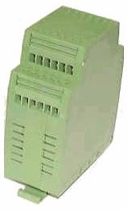
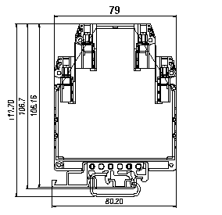
1. Signal Assignment for Isolator Box
The signal assignment for isolator box is defined as following. Consider the top view of isolator box, there are 15 signals are defined as:
Transmit Data | Receive Data
Clear To Send | Request To Send
Signal Ground1
Data Terminal Ready | Data Set Ready |  | Signal Ground2
 | 0V | Receive Data+ | Transmit Data+
 | 24V | Receive Data- | Transmit Data-

Please Note that the DTR and DSR signals are short-circuited from the master to the slave's internal circuits of the box; there is no optical isolation from the master to the slave.
2. DB25 Connector Assignments for RS232
The communication interface follows the EIA RS232 standard. The signal assignments for a standard Data Terminal Equipment (DTE) DB25 connector are shown below:
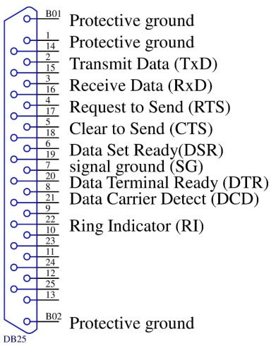
DB25  Pin # Signal Name | RS-232C  Name | Signal  Direction
1. Shield Ground
2 Transmit Data(TxD) | BA | Output
3 Receive Data(RxD) | BB | Input
4 Request to Send(RTS) | CA | Output
5 Clear to Send(CTS) | CB | Input
6 Data Set Ready(DSR) | CC | Input
7 Signal Ground(SG) | AB | Common
20 Data Terminal Ready(DTR) | CD | Output

3. DB9 Connector Assignments for RS232
The signal assignments for a standard Data Terminal Equipment (DTE) DB9 connector are shown below:
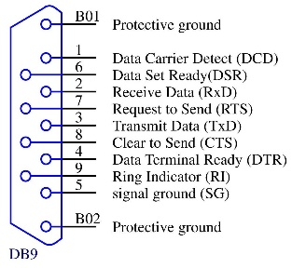
DB9  Pin # Signal Name | RS-232C  Name | Signal  Direction
2 Receive Data(RxD) | BB | Input
3 Transmit Data(TxD) | BA | Output
4 Data Terminal Ready(DTR) | CD | Output
5 Signal Ground(SG) | AB | Common
6 Data Set Ready(DSR) | CC | Input
7 Request to Send(RTS) | CA | Output
8 Clear to Send(CTS) | CB | Input

4. DB25 Connector Assignments for RS422
The communication interface follows the EIA RS422 standard. The signal assignments for a standard DB25 connector are shown below:
Pin | Description
2 | Transmit Data+(TxD+)
3 | Receive Data+(RxD+)
6 | Receive Data-(RxD-)
7 | Signal Ground(SG)
20 | Transmit Data-(TxD-)

5. DB9 Connector Assignments for RS422
The communication interface follows the EIA RS422 standard. The signal assignments for a standard DB9 connector are shown below:
Pin | Description
2 | Receive Data+(RxD+)
3 | Transmit Data+(TxD+)
4 | Transmit Data-(TxD-)
5 | Signal Ground(SG)
6 | Receive Data-(RxD-)

CHAPTER 4
APPLICATIONS

The applications of industrial RS232 to RS422 photo isolator are shown is the following:
1. Connect to RS422 Device
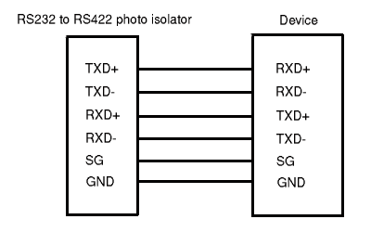
2. For Long Haul Distance Communication
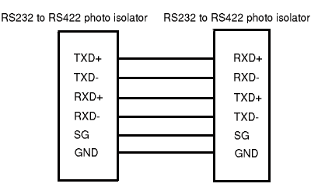
APPENDIX A
WARRANTY INFORMATION

A.1 Copyright
Copyright 2018 DECISION GROUP INC. All rights reserved. No part of RS232 to RS422 isolator may be reproduced, transmitted, transcribed, or translated into any language or computer language, in any form or by any means, electronic, mechanical, magnetic, optical, chemical, manual, or otherwise, without the prior written permission of DECISION GROUP INC.
Each piece of RS232 to RS422 isolator package permits user to use only on a single computer, a registered user may use the program on a different computer, but may not use the program on more than one computer at the same time.
Corporate licensing agreements allow duplication and distribution of specific number of copies within the licensed institution. Duplication of multiple copies is not allowed except through execution of a licensing agreement. Welcome call for details.
A.2 Warranty Information
DECISION warrants that for a period of one year from the date of purchase (unless otherwise specified in the warranty card) that the goods supplied will perform according to the specifications defined in the user manual. Furthermore that the RS232 to RS422 isolator product will be supplied free from defects in materials and workmanship and be fully functional under normal usage.
In the event of the failure of an RS232 to RS422 isolator product within the specified warranty period, DECISION will, at its option, replace or repair the item at no additional charge. This limited warranty does not cover damage resulting from incorrect use, electrical interference, accident, or modification of the product.
All goods returned for warranty repair must have the serial number intact. Goods without serial numbers attached will not be covered by the warranty.
Transportation costs for goods returned must be paid by the purchaser. Repaired goods will be dispatched at the expense of RS232 to RS422 isolator.
To ensure that your RS232 to RS422 isolator product is covered by the warranty provisions, it is necessary that you return the Warranty card.
Under this Limited Warranty, DECISION's obligations will be limited to repair or replacement only, of goods found to be defective as specified above during the warranty period. DECISION is not liable to the purchaser for any damages or losses of any kind, through the use of, or inability to use, the RS232 to RS422 isolator product.
DECISION reserves the right to determine what constitutes warranty repair or replacement.
Return Authorization: It is necessary that any returned goods are clearly marked with an RA number that has been issued by DECISION. Goods returned without this authorization will not be attended to.

